Monday, August 29, 2016

Hscei opened low. With interest rate expectations going up, this round of H share rally is going to be over. From Jun-Aug, this was a time where Fed's interest expectations were lowered

Over the weekend, I went to a lecture, which outlined the three stock market crashes last year. The crash of Aug and Jan2016 were due to China massively devaluing its exchange rate. So it is also important to keep track of China's exchange rate listings.

Markets climbed back on very low volume, before the end of noon, markets tend to trade in momentum. 1110 It is now trying to rally. The opening level is respected though as market fears this level. 1115, market broke daily highs. (China rallied much much stronger than HK, HK's sensitivity to US rates is much higher, looking at HSAHP, H performed much better than A during the 2 months period)

Looking at this morning, it is an example of risk transfer between the risk averse and the risk loving. Risk averse individuals fear the impact of the rate hike, where risk loving individuals choose to go long at this level, even chasing at this point. Once people see that the index stops dropping, they will rush in to buy. Taiwan, Korea and H share all are climbing back up.

A rebounded by 80 bps while H rebounded by 50 bps from the lows this morning.

Futs still at a 30bps premium. People don't think rate hike will affect markets as much. The expected delay in the rate hike propped up H shares much more than the A shares.

In the long run, market reverts to reasonable levels.

Afternoon opens weak. I would not go long here.

Market is breaking lows around 1322. I want to short a bit here. The reason is

1. downward pm trend
2. High percentile
3. negative amFirst10
4. 0.3% premium (1419 @ 0.37p)
5. Daymax is at 931.

Things working against this trade:

1. strength even after a hawkish fed.
2. amclosepercentile closed at the highs
3. consistently at a premium and this signifies market bullishness.

Market broke min around 1335.

In general, effects of US rates on china are a lot less than china's exchange rate. Exchange rate depreciation hurts China's assets, spurring an outflow of assets out of stock market. But with rate rise, China's relatively insulated from this risk. What affected china mainly over the past year is interest rate expectation (within China) and investor risk preference.

The next question is what Europe will do. US stock performance will have an impact on the sentiment of European stocks. Geopolitical risk will translate into more aggressive rate cuts and

@1350 Markets are stubbornly long, won't give up being long.

@1353 markets are selling off a bit here, but the pd remains @ 0.3%. I want some of that premium.

Would you go long or short here? **1359 things are bit strange.** Now the discount is in the middle of the road. 9:30 discount was 0 and during noon pd rushed up to 0.59, which was a time to short. (1359 there was a sudden spike, this was a tell tale sign to reduce positioning)

1410 Markets rushed up @ 0.43% discount.

At this point what is the advantage/disadvantage?

A: Pmmin is late. The last rally pulled in the remaining bulls and cleansed out the bears.

Market is still at a 0.44 premium. How will Europe perform?

From now on I am experimenting with one thing – always have some position on, this forces you to examine the current position.

Discount goes further to 0.48%.

The position is losing money much more quickly than when it was making money.

I don't want to cover here since I only cover at day's lows.

1438 At this point, market is stubbornly long @ +0.39% prem. I am using 40 bps as a cushion. Being short today is a lot more difficult than being long today.

The next question is what will Europe do?

1. assets shifting into Europe

The last half an hour yielded no action. Sitting on the short with 0.33 premium carry o/n.

Heading into the close, discount gave back, showing that there were more sellers than buyers into the close, which in turn shows that there were more net buyers today then sellers.

Trading stops. France and Germany are trading lower but quickly heads higher.

Today the key is to take some profits. The shorting is fine based on the factors mentioned.

Premium protected my ass during the 20 bps rally in the last 15 minutes. Shorting almost yielded no profits if held into the close. The short would have been best placed at noon. But this would be quite risky (in case afternoon rallies). The short was ok but would need to be quickly covered. In terms of today's strategy,

**Tuesday, August 30, 2016**

XU @ 50 bps premium. Sold @ 9777.5 (covered at flat later)

Rational: 50 bps premium. (About 20bps was due to greed)

Risk: Bullish HSCEI, difficult to exit this position if market rallies.

Did you look at yesterday's retPMCO? (No, yesterday PM was a small down, and the closing percentile was 70%)

Do you dare to put the whole position on this trade? (No)

Market moves up 0.1%, futs are at 0.40%P, this level in the long run is quite safe, so it is good to long some delta.

First10 is positive. This sets up some opportunities for being long today.

@ 945 holding up strong here.

Market rallied 30 bps, fut rallied 20 bps. PD @0.31 .

950 Rallies are very strong compared with the retreats. A lot of disagreements here.

952 discount goes to 33 bps. Longs are persistent.

1012 Covered at a small loss here. This level is relatively low and the market is not dropping any further -> cover. With a positive amFirst10, trade long for the rest of the day.

Net position revert to long. Being long is more comfortable at this point. Do a bit of accumulation at these levels.

Underperforming the market today. Yesterday US session was much stronger than expected.

The issue with increasing position size here is that it is not a low point, which means the rally won't be that great.

1039

Markets start breaking up here. Time to start picking up some pos.

1242

Markets trading within 30 bps range. Slowest day in a while.

Afternoon: am had such a small move – this doesn't justify big positions.

Issue with joining MS was putting myself at a disadvantageous position – this lesson would need to be learned. That position at MS basically put me in a low position which affected all aspects of my life in the later part of HK, also it deprived me of other options to move, during interviews with GS(Lambert Lau) and JPM(with Matthew Pau). I got asked questions on my situation as a TA. This was a bad hole to dig out of. This was a very bad career move. Position is better than company name. The time at MS did not earn me $, respect, nor friendship.

Sold off a bit early here about 40 bps. The strategy is indicating to chase but it was hard to go against the instinct to follow the strategy. I had a strong desire to sell because of the need to secure profits. This level is too high to chase now @ 1336 (9827/9787).

Actual trading skills need to be honed. Given that you know the rules, but to implement the trade as required is even more difficult. The start of this rally was at 1317 until 1331. It was short but filled with burst. At this level I am more reluctant to chase.

Re-entered @ 9800. I was waiting for the short to keep liquidating. One principle I have come to discover is most of the chasers (80%) will lose.

1401 Noone trading now, the long and short have been exhausted.

1408 what do I trade here? Leave the long here. You need to learn how to add position to trade a small move.

Mostly, direction is determined by level, after the initial rally, market is out of steam.

@1425 level not attractive.

@1426 Something is about to happen. Enter at 9802. Level is not that attractive so don't go in a lo, the point is train that market sense.

Be patient and wait for a bit here. Level is quite sensitive. Could

Buys were in the AM were good, sell in the early PM (first rally) was premature. The later rallies were energyless rallies.

Market is clueless for the whole day today. Only one tradable move (late AM-early PM trade). Market moves within a 60 bps range today. As people start losing hope, they start selling off into the close. (@1446) The rally @ 1427 was a fake rally. Any chasers in the PM is losing. A lot of liquidation at this point (1449)

So the issue today is that the rally near 1427 was a fake rally, the level was still high compared with today's low range. Only the first PM rally was a real one.

In terms of costing, level is more important than direction.

Only the first rally was good to act on. The second rally could be misleading.

Fut sells off all the way to flat, and PD is under 10%. People seem unwilling to sell below the cash. All of the premiums got killed, people are giving up.

Issues today:

The shorting @ 915 without any information. (Wait before you trade)

2.

Buys @ 1357 & 1427, after the first rally, the energy is wavering and these don't constitute good trading (chasing for reaching high, difficult). (Don't try to revive a dead horse).

Today's ammax is not that great.

Wednesday, August 31, 2016

Market opened slightly up. US was slightly down on narrow range.

Market broke highs around 1048, approaching yesterday's rally level. This index level is good to do intraday trading. Since the level is not too high, a crash is not as likely as before.

@1111 Markets rallying into am close. Sold about 30 bps too early. The problem is you need to put in more than 1 lot so that you are more versatile in trading. 2-3 lots would be better.

Market broke am high near 1109, this is when the index starts to take off.

Market broke yesterday's high, not a very safe level to buy.

Today's advantages and disadvantages:

A:

1. yesterday there was a rally, did not close at the high percentile.
2. It rallies towards the true range
3. Wednesday

D:

Markets @ 40bps premium. Cash chased it all the way into the am close. Missed about 60 bps of move here.

Tomorrow is in danger.

Late morning moves are super strong – either rallying or dropping, on Wednesday, I had experience similar to this on Wednesday Apr 20th. I didn't join on prime time – I am not going to participate at this level.

**Research topic:**

How to take advantage of late morning moves. Especially if index breaks day low/high around 11am. 20 bps chase

Especially

1337 Percentile here is quite high and with a

1403 slow move down at a high percentile -> don't join.

There is a limited amount of buying potential everyday, once that's exhausted, it is hard to redo the same again. The late morning rally exhausted pretty much all of its power.

1416 This level could consider going in. But level is high and market participants don't want to chase because it's Thursday .

Volume is very low in the afternoon and a lot of the morning buys are underwater.

1421 Market has a potential to head up here.

Go into the first principles behind of the research result that two day afternoon have negative correlation, it is reverting back to the true range (most likely oversold). This morning it was apparently overbought, and markets are paying for the price now.

If I don't dare to go into with full position, then you shouldn't go in at all, daring to go in with full position means that you are somewhat certain about the probability of trade.

1426 action is about to start here. Don't forget what happened yesterday though, there was no energy to push up the market. Note the level of your trade. If the morning session was miserable and there were all sellers then it might be good to buy.

**Buy on the first release of buying desire.** This means at the bottom of a range or index hasn't risen at all for the day, this is the more sure scenario.

Develop a tool to quickly

Thursday, September 01, 2016

Let's see about the first ten.

Futs go lower in the morning.

I missed the prime opportunity to short this morning at a premium.

Now the amFirst10 is positive.

After an initial period of oversell, markets quickly rally back.

You were tempted to short @ 9810 but this was a low and too much was sold initially, you were exposed negatively to the short squeeze. Think first principles -> sell only when greed, if you follow the shorts into 935, this would most likely be a bad choice. When markets open, moves tend to be exaggerated. Wait until the true trend appears. Yesterday markets started to rally after 1030, and this was a good place to go in.

Yesterday's retPMCO was low but closing percentile is high, this is a contradiction. There are not enough precedents to judge this scenario. (retpmcoy < 0 & percentiley>0.9)

Now people roughly agree that it wont be a panic selling session (at least not yet)

A is much stronger than H due to china's insensitivity to the rates.

958 market rallies up (this move is strange on no volume)

1010 Markets had a good rally up until here.

1017 I shorted a unit here.

Rationale?

1. percentile is attractive (OK)
2. Yesterday's pm percentile
3. Good trading is based on level, not direction

Dis:

1. ammax is past 10
2. amfirst10>0
3. broke the high at 1019 here again. Has the potential to go much higher.

Morning it's mostly gambling if held from beginning to end. Afternoon offers a core advantage especially for percentileY<0.6, this is the basis for increased position size.

Markets are slow now but you should have an engine for testing when markets move fast.

Recap: Look at the relative level over a multi-day period (especially 2 day and week to date). Try to determine the average entry cost of traders, and determine if it is an attractive level. Trade level, not direction.

**Friday, September 02, 2016**

Market opened and rallied up. I only picked up 1 lot yesterday whereas I should have picked up more. 2/3 of the market is gone.

@9795 picked up 1 lot.

Most of the chasers will lose money. Yesterday it would be better to come into today with 2 lots, and sell some position at the beginning of today.

The amFirst10 today is good, coupled with yesterday's low percentileY things look promising. Afternoon first10 is the only thing that can possibly screw things up.

Being long here is comfortable vs. being short, market hasn't rallied past yesterday's midlevel yet.

@1002 sold off fast here, meaning some are giving up on the morning, there are heavy pressure near 9795 level. There are some large order algo here. The index is being heavily suppressed here. Be ready for further drops here, if noon closes at a low percentile that would be ideal.

@1013 Hard for shorts here.

@1016 A lot of argument here. People are still scared from yesterday.

@1019 Result coming out soon.

@1035 market rallied about 40 bps from low to high.

@1036 market stagnates, and the washing begins. This might last until late morning/early afternoon. Any low point is a buying point.

@ now until the amclose would be not good buying points.

@ There might be a 30-50 bps of adjustment from here. The true rebound will come after 1:30 ish, but I don't want to have 0 position here, so will need to suffer some variation.

@1042 Incredibly resilient as we already have a 40 bps premium. (93% percentile PD). Now we will need to look at amclosepercentile and pmFirst10.

@1048 Selling pressure is huge here. Futs still holding on. Impressive.

@1054 Futs premium shaving off a bit, as traders

@1055 traders keep pushing index into 40 bps premium as afternoon poses good opportunities.

@1114 As expected, markets retreated for about 30 bps. XU is still at 59% percentile tho. PD at 0.44 which is 100% percentile PD. I don't want to buy here (cash @ 9770).

@ Risk can titrated a little bit at a time. What's important is to synthesize everything you know.

@1130 market rallies into the close. Discount persistent @ 0.4.

@1304 Market selling off a bit in early afternoon.

@1309. Market bled for pmFirst10.

@1313 Market quickly goes to 41bps premium again. Upon any move in the underlying, fut overreacts it, showing readiness to dive in.

Adv

1. percentileY
2. AmmaxT ~ 10, ammin @ open
3. amcloseP not at highest
4. amFirst10 is positive

Disadv

1. pmfirst10 negative
2. Morning already recovered all the losses from yesterday afternoon.

@1321 index breaking lows here. The situation doesn't look that great. People are selling. The advantages are not great, mainly due to its Friday. If it was Wednesday, it would not be sensitive to pmFirst10.

Longs are washed out here. The question is should I add position here?

@1330 Bought @ 9795. Reason is this level is at shcomp day low here. I am trading average percentileY change here (now it is 0th percentile).

@1332 People are very scared here.

@1334 Washed off some people here.

@1347 market still Selling off. Tough here.

@ 1349 Pd goes to 40 bps again. Index is still heading down. Holding a position through this is tough.

@1351 Haphazard outbursts here.

@1357 Range becomes smaller and smaller. Volume goes to 0, premium is still @ 30 bps. Not an idea situation.

@1404 I got hit… forgot to take off the bid. (This actually was a good opportunity to trade in hindsight, it was a fast drop that invited shorting)

@Tough session. The opportunities are haphazard.

@1411 Some chance of break out here, not chasing.

@1413 Breakout is around the corner.

@ 1425 The washing is extreme. How many rounds of washing has gone by…

@1436 PD goes to 25bps.

@1442 Market

@1445 Market broke day high here. Is it time to chase? Percentile wise it's not that good to chase. PD is reducing fast. Ten minutes are left.

@1449 PD under 20 bps.

@1502 PD goes to 10 bps.

@1506, lot of position cutting here by intermittently hitting the bid. Discount is now at 6bps. That's 30 bps lost from 2pm.

@1641 In the morning, market traded at a consistent premium throughout the AM session. Premium topped out at 11am. As cash rallied in the PM, futs gradually reduced its premium to close at flat.

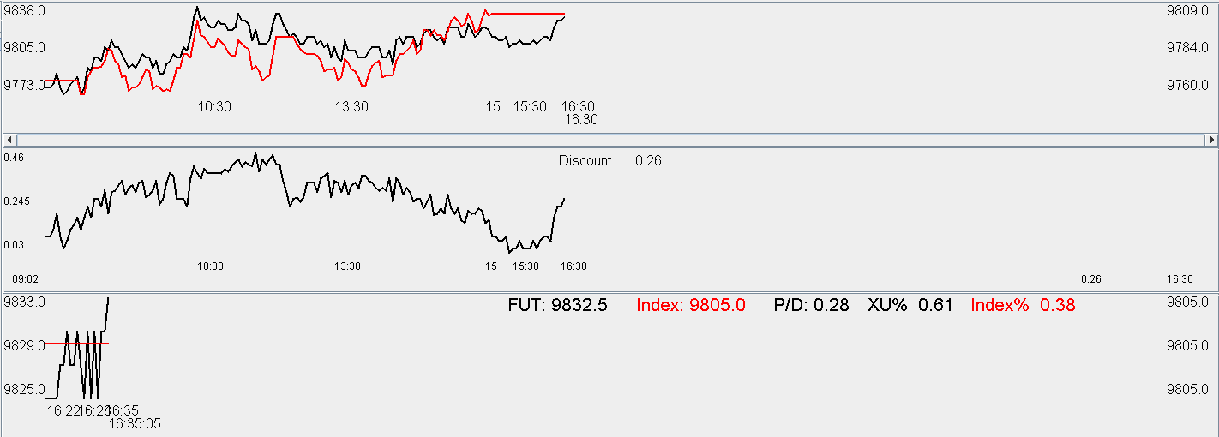

I want to grow the advantage further to the fullest.

Position sizing.

weekly review:

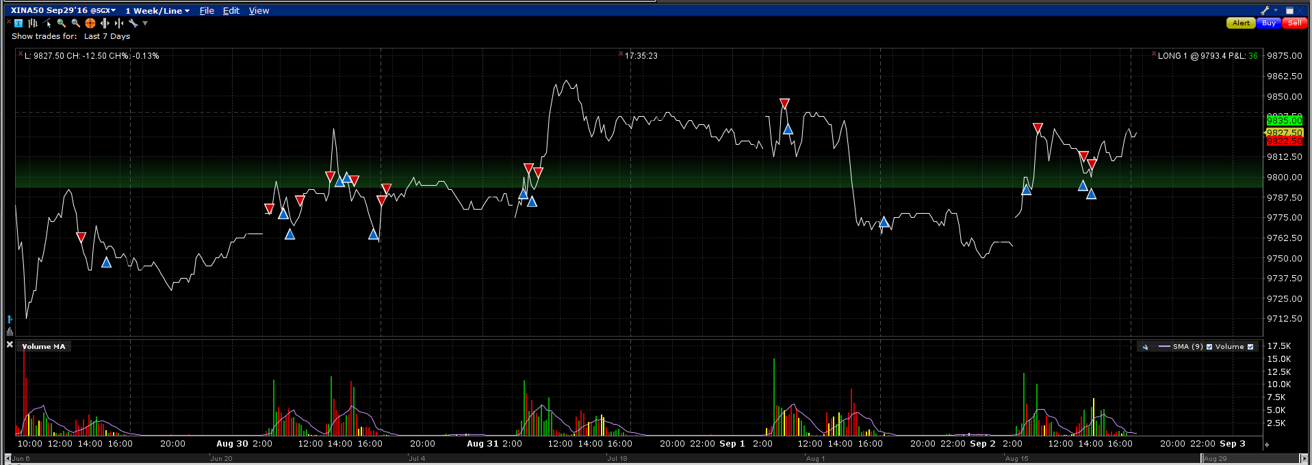

What knowledge did I use to make money this week?

Opportunity missed/issues:

1. buying on the AM low on Monday (at this level, there's not as many crashes as before
2. Tuesday afternoon: long strengthen was exhausted in the PM, be careful not to buy too much in the PM
3. Wednesday there was no position on although fut was breaking AM highs (Escaped the PM session because amClosePerc was high and pmFirst10 was negative)
4. Went to the beach on this day. Evaded the PM move.

Key skills:

1. From market moves, you can feel the market strength
2. Level is very important, at high level, stagnation means going lower, at low level, inability to drop lower means going higher
3. Day to day overlap is very obvious.
4. Not afraid to buy on Tuesday, Thursday close at the low.
5. Every day has a certain amount of reservoir for rallying, if that strength is exhausted, then it is hard to get it moving again